Version 1 (original)

Participants imagine or view coin flips with a specific outcome for 10 trials. Then in the last trial, they **imagine** an outcome that is $-3μ$ in value. We check how this outlier trial is combined in the gamble decision phase.

We will test this incorporation of outlier trials in imagination blocks and view block separately. We will use different coin for each block. The gamble phase result will not be presented to participants (to prevent learning).

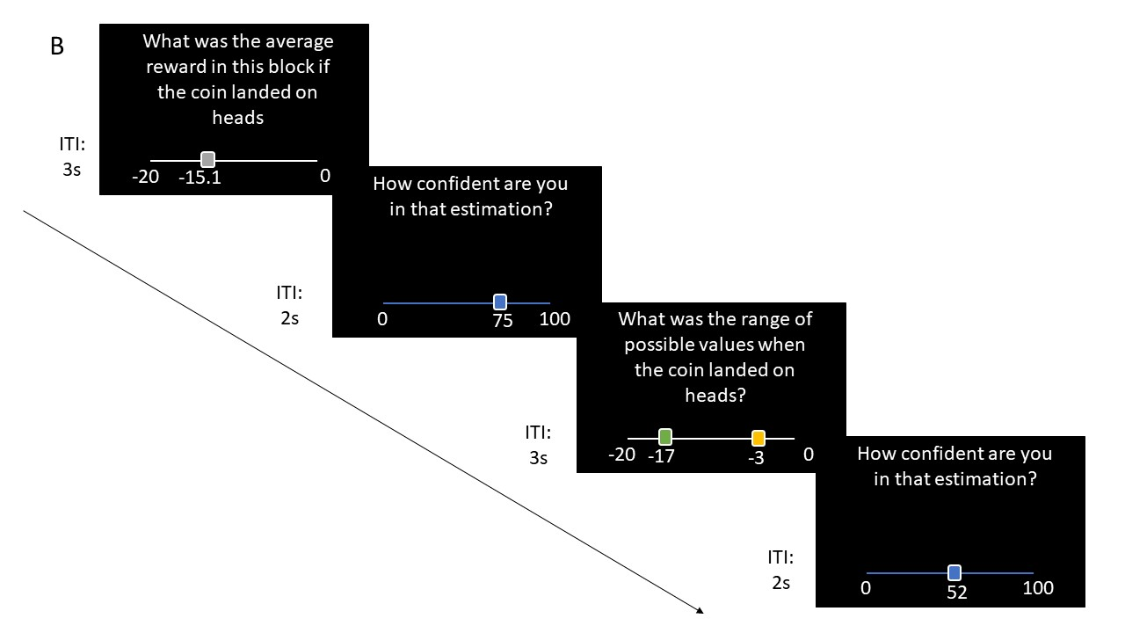

Version 2

Interchangeable imagination of view trials (non-blocked), for example 4 trials each, in some blocks, the distribution of the coins in the imagination trials are identical to the distribution of the coins in the view trials in other blocks the distributions are different. Then, without an outlier trial, we check how participants adapt when gambling, according to different levels of similarity between distributions.

Version 2.1

Similar instructions, but before the decision trial, the participants are actively being asked to include or not include the imagination trials in their decisions.

Version 3

Participants learn initially that using the imagination as context is valuable by incremental learning in the gamble phase, i.e., the results of the gamble phase are a result of a combination of both the imagination trial and the view trials. At some point, we remove this relationship, and results of the gamble phase are dependent only on the view trials. Participants will be tested on their ability to flexibly not use the imagination trials in coming trials.

In this version, a simpler task is probably required, so that participants will be able to track the changes in outcomes more easily. For example, a simple coin toss with a constant value.

**Manipulation checks**

Should the manipulation check questions ask in general about the average reward the coin landed on heads? Or should they separate between imagination and view trials. Perhaps, in version 2-3 we should separate the questions.